Bank Reconciliation in NetSuite
Bank Data Matching, Intelligent Transaction Matching, Account Reconciliation, and GL Impact
Weekly Learning Series – Week 18

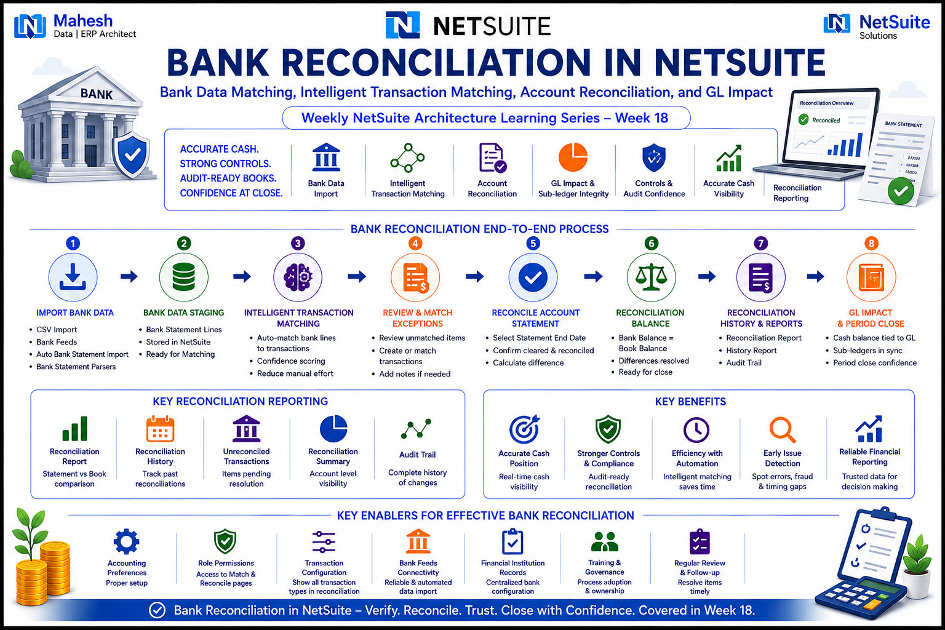

1. Introduction
Bank Reconciliation is the control process that confirms the cash balance recorded in NetSuite's General Ledger agrees with the balance reported by the financial institution. It closes the loop on the Order-to-Cash and Procure-to-Pay cycles by verifying that every posted bank transaction — deposits, payments, fees, and transfers — has actually cleared the bank, and that nothing on the bank statement is missing from the books.
Bank Reconciliation is delivered through two generations of functionality: the legacy Reconcile Bank Statement and Reconcile Credit Card Statement pages, and the redesigned Bank Data Matching and Reconciliation feature built around the Match Bank Data and Reconcile Account Statement pages. The redesigned feature uses Intelligent Transaction Matching to automatically pair imported bank lines with account transactions, reducing reliance on spreadsheets and manual entry.
📌 Why Bank Reconciliation Architecture Matters
- Reconciliation is the final control gate confirming GL cash balances are audit-ready before period close
- Intelligent Transaction Matching automates the pairing of bank lines to transactions, cutting manual review effort
- Unreconciled differences surface errors, timing gaps, duplicate postings, and potential fraud before they compound
- The Statement End Date becomes the Close Date used to drive Reconciliation and Reconciliation History reports
- Reconciliation status (cleared and reconciled) is a prerequisite many organizations enforce before closing an accounting period
- Understanding both reconciliation generations is essential, since older NetSuite accounts may still run on legacy pages

1.1 Bank Reconciliation in the NetSuite Architecture Stack
Bank Reconciliation sits downstream of every subledger that touches a bank account. It is the verification layer between transaction posting and period close.
Upstream Module | Action | Reconciliation Impact
Accounts Payable | Bill Payments / Checks Issued | Outstanding checks tracked until cleared by the bank
Accounts Receivable | Customer Payments / Deposits | Deposits matched against bank deposit lines via Intelligent Transaction Matching
Banking | Bank Transfers, Bank Fees, Interest | Cleared directly against the bank account register
Bank Feeds / Imports | Imported Bank Statement Lines | Source data for the Match Bank Data page
General Ledger (R2R) | Cash Account Postings | Reconciled balance must tie to the GL cash balance at period close

2. Bank Reconciliation Architecture — Two Generations
The original Reconcile Bank Statement and Reconcile Credit Card Statement pages are no longer supported as of NetSuite 2021.1 and will eventually be removed. The redesigned Bank Data Matching and Reconciliation feature replaces them, centered on the Match Bank Data and Reconcile Account Statement pages.
For newly created accounts, NetSuite automatically enables the “Use Match Bank Data and Reconcile Account Statement Pages” setting. For existing accounts still on the legacy pages, an administrator must clear or set this box on the Edit Account record to migrate the account to the redesigned workflow.

2.1 Legacy vs. Redesigned Reconciliation Pages
Aspect | Legacy (Reconcile Bank/Credit Card Statement) | Redesigned (Match Bank Data + Reconcile Account Statement)
Status | No longer supported as of NetSuite 2021.1 | Current and actively developed
Matching Method | Manual selection of cleared transactions on the statement page | Intelligent Transaction Matching auto-matches imported bank lines to transactions
Bank Data Source | Manually marked as cleared by the user | Imported via CSV, Bank Feeds, Auto Bank Statement Import, or Bank Statement Parsers
Navigation | Transactions > Bank > Reconcile Bank Statement | Transactions > Bank > Match Bank Data, then Reconcile Account Statement
Account Setting | Use Match Bank Data and Reconcile Account Statement Pages — unchecked | Use Match Bank Data and Reconcile Account Statement Pages — checked

⚠️ Architectural Note: Permissions and Custom Transactions
- Proper role permissions are required to access the Match Bank Data and Reconcile Account Statement pages
- To reconcile custom transaction types, enable “Show All Transaction Types In Reconciliation” in General Accounting Preferences
- International deployments may require manual adjustments for special taxes (for example, GST) during reconciliation
- A reconciliation can be started and resumed later — NetSuite preserves in-progress work until it is saved

3. Bank Data Import Architecture
Intelligent Transaction Matching depends on bank statement data being imported into NetSuite. The platform supports several import pathways, each suited to a different connectivity scenario with the financial institution.
Import Method | Mechanism | Best Suited For
CSV Import | Manual upload of a bank-exported statement file | Banks without a direct feed; ad hoc or low-volume accounts
Bank Feeds SuiteApp | Direct connection to supported financial institutions | Daily automated bank line retrieval without manual export
Auto Bank Statement Import SuiteApp | Scheduled, automated statement file ingestion | Recurring imports from institutions that deliver statement files
Bank Statement Parsers SuiteApp | Parses statement files into NetSuite's expected import format | Institutions whose statement format requires translation before import
Financial Institution Records | Stores connectivity details for a given bank relationship | Centralizing institution-level configuration for feeds and imports

4. Intelligent Transaction Matching
Per Oracle NetSuite documentation, when bank data is imported or reconciliation rules are run manually, Intelligent Transaction Matching automatically matches imported bank lines with account transactions using two categories of rules. The feature does not run rules against transactions that are already matched, regardless of reconciliation state.

4.1 System Rules vs. User Rules
Rule Type | Definition | Configuration
System Rules | Default matching rules built into NetSuite; cannot be changed or removed | Listed on the System Rules list of the Reconciliation Rules page
User Matching Rules | Custom rules that auto-match bank lines to transactions meeting defined criteria | Created and ordered on the Reconciliation Rules page; reusable across accounts
Auto-Create Rules | Automatically creates and matches deposits/charges (GL bank accounts) or charges/refunds (credit card accounts) | Generated from the Match Bank Data page during a one-to-one match; one rule per account

4.2 In-Transit Payment Matching
In-transit payments are non-posting transactions and are not eligible for matching through system or user rules. Instead, NetSuite applies a built-in rule requiring the transaction number and amount of the in-transit payment to match the imported bank line, which must be a Payment-type line.
⚠️ Architectural Note: Ambiguous Matches
- If a rule finds two or more equally valid matches, NetSuite cannot auto-select one and flags it for manual review
- Example: a $70 imported deposit could match either of two prior $70 deposits — the user must choose the correct one
- On the Review subtab, matched line items appear collapsed as groups; expand a line to inspect individual transactions
- Automated Cash Application should be run before manual matching to auto-generate and clear eligible customer payments

5. Match Bank Data Page Workflow
The Match Bank Data page (Transactions > Bank > Match Bank Data) presents side-by-side grids of imported bank lines and NetSuite account transactions, enabling reconciliation without spreadsheets or third-party tools.
Step | Action | Description
1 | Match Account Transactions | Pair imported bank lines with corresponding NetSuite transactions, either automatically via rules or manually
2 | Mark Cleared Pending Submission | For transactions with no matching bank line, mark them cleared directly without an imported line
3 | Exclude Imported Bank Lines | Remove bank lines that do not correspond to any valid NetSuite transaction
4 | Review Matched and Cleared Transactions | Inspect matched groups and user-cleared transactions before finalizing
5 | Submit | Submit reviewed transactions to clear them in the system, making them available on Reconcile Account Statement

If account statements exist but importing them is impractical, transactions can be marked cleared directly in NetSuite without importing matching bank lines at all. Customer payments generated and cleared through the Automated Cash Application feature also surface automatically on the Reconcile Account Statement page.

6. Reconcile Account Statement Page
Once transactions are cleared and submitted from Match Bank Data, the formal reconciliation is completed at Transactions > Bank > Reconcile Account Statement. This page compares the cleared, submitted transactions against the statement's ending balance to confirm the account is fully reconciled.

6.1 Key Fields on the Reconcile Account Statement Page
Field | Behaviour
Account | Determines the default subsidiary and currency, and filters the open transaction lines accordingly
Statement End Date | Defaults to the end date of the most recent statement; becomes the Close Date and cannot be changed later
Ending Statement Balance | Defaults to the closing balance from the most recent statement, or the last reconciliation if no statement exists
Last Reconciled Balance | Balance of the account from the previous successful reconciliation
Difference | Amount remaining to reconcile; zero indicates the reconciliation is complete
Deposits and Credits Subtab | Lists deposits and credits to be reconciled; shows Yes in the Cleared column for transactions already cleared on the register
Checks and Payments Subtab | Lists checks, payments, and credit card refunds to be reconciled, with the same Cleared indicator

6.2 Difference Field Calculation
NetSuite calculates the Difference field as follows:
Difference = Ending Statement Balance
− (Last Reconciled Balance + Reconciled This Statement)

Reconciliation is complete when Difference = 0
📌 Reconciliation Completion Mechanics
- Mark All Cleared to Reconcile updates every already-cleared register transaction for inclusion in one action
- Transactions must be both Cleared and Reconciled before a period can be considered closed for that account
- If more transactions arrive for an already-reconciled date range, the statement must be deleted and recreated to include them
- Using a Statement End Date in the past avoids excluding same-day transactions received after reconciling
- A reconciliation in progress is preserved by NetSuite and can be resumed and saved at a later time

7. Account Reconciliation Reports
After reconciling, NetSuite provides a set of reports that document the process for audit trail and management review purposes. Reports should be printed or exported before reconciling the next account, since the data cannot be recaptured afterward.
Report | Navigation | Purpose
Bank Register | Reports > Banking/Budgeting > Bank Register | Chronological register of all transactions posted to the bank account
Reconciliation Summary | Reports > Banking/Budgeting > Reconciliation | Beginning/ending balances, cleared vs. outstanding totals, and the difference between reconciled and unreconciled balances
Reconciliation Detail | Reports > Banking/Budgeting > Reconciliation > Detail | Line-by-line list of cleared and uncleared items, grouped into Deposits and Other Credits, and Checks and Payments
Reconciliation History | Reconcile Account Statement > Reconciliation History Report (or History on legacy pages) | Audit log of past reconciliations performed on the account

8. GL Impact of Bank Reconciliation Activity
Reconciliation itself does not post journal entries — it verifies balances that other transactions already posted. However, the discrepancies it surfaces routinely require GL entries to bring the books in line with the bank. R2R architects should understand both the timing differences that need no entry and the true discrepancies that do.
Reconciling Item | Debit | Credit | R2R Impact
Bank Service Charge | Bank Charges Expense | Cash / Bank Account | Reduces GL cash balance; must be entered before the bank and book balances will tie out
Interest Earned on Account | Cash / Bank Account | Interest Income | Increases GL cash balance to match bank-reported interest credit
NSF / Bounced Customer Check | Accounts Receivable | Cash / Bank Account | Reverses the original cash receipt; AR balance restored, customer becomes collectible again
Deposit in Transit | No entry required | No entry required | Timing difference — recorded in the books, not yet shown on the bank statement; resolves itself next cycle
Outstanding Check | No entry required | No entry required | Timing difference — issued and recorded, not yet cleared the bank; tracked until it clears
Bank or Posting Error | Varies by error type | Varies by error type | Corrective journal entry required only when the error originated in NetSuite, not the bank
Wire / Transfer Fee | Bank Charges Expense | Cash / Bank Account | Reduces GL cash balance for fees the bank deducted automatically

9. SuiteScript 2.1 — Bank Reconciliation Automation
SuiteScript 2.1 can extend reconciliation visibility beyond the native UI by reading cleared status and reconciliation fields directly from transaction and account records, enabling custom dashboards or pre-close validation scripts.

9.1 Reading Transaction Cleared Status Programmatically
/**
* SuiteScript 2.1 — Check Cleared Status of Bank Transactions
* Oracle NetSuite Docs Reference:
* docs.oracle.com/en/cloud/saas/netsuite/ns-online-help/
* chapter_4842302228.html
*/
define(['N/search'], function(search) {

function getUnclearedTransactions(bankAccountId) {
var unclearedSearch = search.create({
type: search.Type.TRANSACTION,
filters: [
['account', 'anyof', bankAccountId],
'AND',
['cleared', 'is', 'F']
],
columns: [
'tranid', 'trandate', 'type', 'amount', 'cleared'
]
});

var results = [];
unclearedSearch.run().each(function(result) {
results.push({
tranId: result.getValue('tranid'),
date: result.getValue('trandate'),
type: result.getValue('type'),
amount: result.getValue('amount')
});
return true;
});
return results;
}

return { getUnclearedTransactions: getUnclearedTransactions };
});

9.2 Pre-Close Validation — Scheduled Script
/**
* SuiteScript 2.1 — Scheduled Script: Flag Stale Outstanding Items
* Alerts AR/AP teams to long-outstanding uncleared transactions
* before period close.
*/
define(['N/search', 'N/email', 'N/runtime'], function(search, email, runtime) {

function execute(context) {
var staleSearch = search.create({
type: search.Type.TRANSACTION,
filters: [
['cleared', 'is', 'F'],
'AND',
['trandate', 'onorbefore', 'thirtydaysago']
],
columns: ['tranid', 'trandate', 'amount', 'account']
});

var count = staleSearch.runPaged().count;
if (count > 0) {
log.audit({
title: 'Stale Uncleared Transactions Found',
details: count + ' transactions uncleared 30+ days'
});
}
}

return { execute: execute };
});

10. Architect's Quick Reference — Bank Reconciliation Decision Framework
Design Decision | Recommended Approach | Oracle Documentation Reference
Reconciliation page generation | Migrate existing accounts to the redesigned Match Bank Data + Reconcile Account Statement pages | Editing Accounts to Use the Match Bank Data and Reconcile Account Statement Pages
Bank data ingestion method | Use Bank Feeds or Auto Bank Statement Import for high-volume accounts; CSV for low-volume or unsupported banks | Bank Data Import
Custom transaction types | Enable Show All Transaction Types In Reconciliation if custom transaction records post to bank accounts | General Accounting Preferences
Ambiguous-match handling | Build narrowly-scoped User Matching Rules to reduce multi-candidate matches requiring manual review | Creating User Transaction Matching Rules
Statement End Date selection | Use a past date, not the current date, to avoid excluding same-day transactions from the next cycle | Reconciling Transactions
Reporting cadence | Run Reconciliation Summary monthly at close; export Reconciliation Detail and Bank Register before reconciling the next statement | Account Reconciliation Reports

📌 Week 18 Learning Summary — Bank Reconciliation in NetSuite
- The legacy Reconcile Bank/Credit Card Statement pages are unsupported as of NetSuite 2021.1; the redesigned Bank Data Matching and Reconciliation feature is current
- Intelligent Transaction Matching auto-pairs imported bank lines to transactions using System Rules, User Matching Rules, and Auto-Create Rules
- The Match Bank Data page is the working area for matching, clearing, excluding, and submitting transactions before formal reconciliation
- The Reconcile Account Statement page finalizes the process; the Difference field must equal zero for reconciliation to be complete
- The Statement End Date becomes the Close Date and cannot be changed afterward — always use a past date
- Account Reconciliation Reports (Bank Register, Summary, Detail, History) provide the audit trail for period close documentation
- Timing differences (deposits in transit, outstanding checks) require no GL entry; true discrepancies (bank fees, NSF checks, interest) do
- SuiteScript 2.1's N/search module can read the cleared field on transactions to power custom pre-close validation

